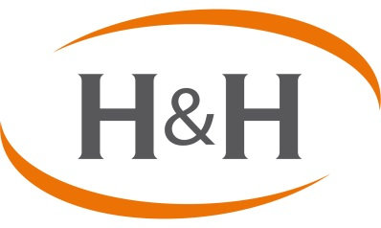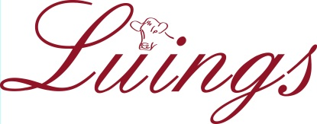

Harrison & Hetherington, Luing Cattle Society Ltd., Mount Blair,
Newton, St Boswells, Melrose, TD6 0PP 10 Manor Gardens, Blairgowrie, Perthshire, PH10 6JS
Tel. 01835-822214 secretary@luingcattlesociety.co.uk/01250-872897

2nd AUTUMN SALE OF LUING BREEDING STOCK
AT THE ST BOSWELLS MART (TD6 0PP)
ON THURSDAY 26TH OCTOBER 2017

Entries and enquiries to Breed Secretary: Luing Cattle Society Ltd., Mount Blair, 10 Manor Gardens, Blairgowrie, Perthshire, PH10 6JS (secretary@luingcattlesociety.co.uk or 01250-872897).

ENTRIES CLOSE Friday 22nd September: ALL ENTRIES TO BE SENT TO THE LUING CATTLE SOCIETY

1 | The order of the sale will be: Pedigree Luings will be sold first followed by registered Sim-Luings and then Luing crosses. In-Calf Heifers (class 1); Bulling Heifers (2); Heifer Calves (3) Cows (in-calf and/or at foot - 4).
2 | Every consigning herd must be a member of a CHeCS accredited health scheme and all stock must be vaccinated against BVD (vaccination details to be included with the entry form). If herds are not accredited free of BVD, then sale animals must be tested virus negative (test results to accompany entry form). There will be no separate facilities for IBR accredited animals at this sale.
3 | All cross-bred stock entered must have at least one registered parent; i.e. must be sired by a pedigree Luing bull, or the dam must be a pedigree, A-grade or B-grade Luing cow or a registered Sim-Luing. The ear tag number of the registered parent must be provided on the entry form for such cross-bred cattle.
4 | Pedigree and registered cattle will be catalogued with their Herd Book Number.
5 | Official UK tag numbers must be given relevant to all animals entered in the sale and the onus is on the vendor to ensure that each animal is correctly double tagged before entering the sale ring.
6 | Animals to be sold in the ring as a group must be bracketed together on the entry form and must be entered in the order that they will be presented for sale. Heifers can be sold in lots of any number. Each owner’s entries will be sold in one draw unless they number more than 20 in total.
7 | Heifers to be entered in either of the pairs competitions can be drawn from different pens and all but the winning pair will be presented through the ring as originally entered in the catalogue. The winning pair must be sold as a pair within the vendor’s lot at a point of their choosing, to be notified to the auctioneer before the beginning of the sale.
8 | In the case of in-calf heifers, due date and service sire must be given.
9 | All relevant documentation, including pedigree certificates, must be handed to the auctioneers upon arrival at the mart.
10 | The cattle will be sold through one dedicated section and vendors must be full members of the Luing Society.
11 | A commission of 5.95% shall be paid. 3.95% to Harrison & Hetherington, 2% to the Luing Cattle Society. The sale will be conducted in pounds.
12 | Entries to be returned no later than Friday 22nd September to Luing Cattle Society.

Please note that conditions 5 and 6 will be strictly adhered to. Entries will only be accepted if all official UK tag numbers are advised at the time of entry and animals lotted in groups in sale order on the entry form.

CONDITIONS OF SALE:
- Cash: The right of property in goods shall not pass to the buyer until the price is paid to the Auctioneers.
- Interest chargeable from date of purchase at 8% over Bank of Scotland Base Rate.
- Breeding stock are offered for sale under the National Beef Association’s standard terms and conditions of sale and both purchasers and sellers are advised to acquaint themselves with the breeding warranty claim time limits. Please note that the NBA warranty can be extended by advising the Auctioneer in writing within 7 days of the sale of the month in which it is proposed to run the heifers with a bull. Please Turn Over

THE LUING CATTLE SOCIETY LTD.

AUTUMN SALE
Thursday 26th October 2017 . . . St Boswells Mart

- List animals for sale by Herd Book Number (or Management Tag). Official UK tag numbers must be supplied.
- Bracket together animals that you wish to be sold in the ring as a group.
- In the case of in-calf heifers, give due date and service sire.
- Note rules regarding pairs of cattle to be shown.
- Include any information about health schemes/status that you wish printed in the catalogue on the separate form.
- Return entries as soon as possible and no later than Friday, 22nd September 2017 along with the Heath Declaration Form.

Entries and enquiries to Breed Secretary: Una MacQueen, Luing Cattle Society Ltd., Mount Blair, 10 Manor Gardens, Blairgowrie, Perthshire, PH10 6JS
secretary@luingcattlesociety.co.uk or 01250-872897.

NAME:…………………………………………………………………………………………………
ADDRESS :…………………………………………………………………………………………..
………………………………………..POSTCODE : ……………………………
TEL NO. : ………………………………
PREFIX: …………………………………………. UK HERD NO. : …………………………
CLASS | HERD BOOK NO. | OFFICIAL TAG NO. | DATE OF BIRTH
e.g. 2 | P/30221 | UK542231/100564 | 01/04/2016

