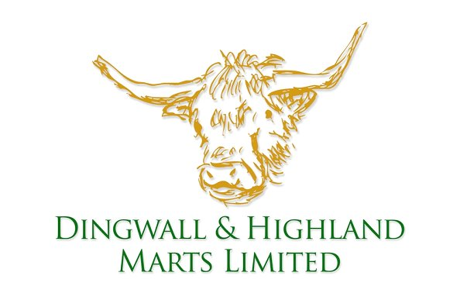
l
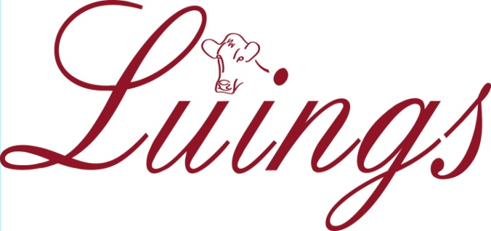

Dingwall & Highland Marts Ltd. Luing Cattle Society Ltd, Mount Blair,
Humberston, Bailechaul Road, Dingwall, IV15 9TP 10 Manor Gardens, Blairgowrie, Perthshire, PH10 6JS
Tel. (01349) 863252 Fax. (01349) 865062 secretary@luingcattlesociety.co.uk / 01250-872897

SPRING SALE OF LUING BREEDING STOCK
AT DINGWALL AUCTION MART

ON WEDNESDAY 16TH MAY 2018

- All bulls must be inspected prior to the sale. Bulls will then be weighed and measured in the market and must measure a minimum of 52inches at the shoulder on the day of the sale with a minimum scrotal circumference of 38cms.
- Every consigning herd must be a member of a CHeCS accredited health scheme and all stock must be vaccinated against BVD (vaccination details to be included with the entry form). If herds are not accredited free of BVD, then sale animals must be tested virus negative (test results to accompany entry form).
- Pedigree and Appendix A Luing heifers may be sold. Older pedigree stock in good condition may be sold at the end of the main sale.
- The order of the sale will be: In-Calf Heifers (class 1); Bulling Heifers (class 2); Yearling Heifers (Class 3); Cows (in-calf and/or at foot - class 4); Bulls (Class 5);
- Bulls must be available for inspection by 0800hrs on Wednesday 16th May. Any animal that fails the inspection cannot be sold under the society sale and must be removed from the sale pens. All females must be numbered and available for inspection by the fieldsman, by 09.30hrs on Wednesday 16th May. Any animal with a black nose or displaying unruly temperament will be rejected.
- Bulls will be catalogued and sold in age order, with oldest first.
- Heifers will be sold in lots of any number, starting with in-calf heifers (or with calf at foot). Each owner’s entries will be sold in one draw unless they number more than 20 in total.
- Official UK tag numbers must be given relevant to all animals entered in the sale and the onus is on the vendor to ensure that each animal is correctly double tagged before entering the sale ring. All animals presented in the ring are expected to be clean and groomed, as befitting a Pedigree Sale.
- All animals will be sold under the terms and conditions contained in the N.B.A. breeding warranty.
- A commission of 5.75% shall be paid. (3.75% to auctioneers, 2% to the Luing Cattle Society).

N.B. ENTRIES CLOSE FRIDAY 13th APRIL 2018 This will be strictly adhered to,
to allow time for compilation, printing and distribution of catalogues.
Enquiries: Breed Secretary: 01250-872897
e-mail: secretary@luingcattlesociety.co.uk

Entries close Friday 13th April 2018

THE LUING CATTLE SOCIETY LTD.

SPRING BREEDING SALE
Wednesday 16th May 2018 . . . Dingwall Auction Mart

- List animals for sale by Herd Book Number or Management Tag. Official UK tag numbers must be supplied. Pedigree certificates no longer need to accompany the entry form and instead should be handed into the mart office together with the cattle passports.
- Bracket together animals that you wish to be sold in the ring as a group.
- In the case of in-calf heifers, give due date and service sire.
- Note rules regarding pairs of cattle to be shown.
- Include any information about health schemes/status that you wish printed in the catalogue on the separate form.
- Return entries as soon as possible and no later than Friday, 13th April 2018 along with the Heath Declaration Form.

Entries and enquiries to Breed Secretary: Una MacQueen, Luing Cattle Society Ltd.,
Mount Blair, 10 Manor Gardens, Blairgowrie, Perthshire, PH10 6JS
secretary@luingcattlesociety.co.uk or 01250-872897.

NAME : ……….………………………………………………………………………………………………………
ADDRESS : …………..………………………………………………………………………………………………..
POSTCODE : ……………………………………… TEL NO. : ……………………………… PREFIX: ……………………………………… UK HERD NO. : ………………………………….
Email :………………………………………………………………………………………………………..

CLASS | HERD BOOK NUMBER | OFFICIAL UK TAG NUMBER | DATE OF BIRTH
e.g. 2 | P/30221 | UK542231/100564 | 01/04/2015

CLASS | HERD BOOK NUMBER | OFFICIAL UK TAG NUMBER | DATE OF BIRTH
e.g. 2 | P/30221 | UK542231/100564 | 01/04/2015

